Retail Sales Analytics – Insight Summary

Objective of the Analysis
The purpose of this analysis was to understand overall retail sales performance by examining sales, profit, product categories, locations, time trends, and customer payment preferences. The aim was to convert raw sales data into meaningful insights that highlight patterns, strengths, and areas for improvement.

Dataset Overview
- Total Records Analyzed: 1,194 orders
- Time Period Covered: March 2020 – March 2025
- Key Measures: Sales Amount, Profit, Quantity
- Key Dimensions: Category, Sub-Category, State, Time (Month/Year), Payment Mode
Basic data checks were performed to ensure accuracy, including removal of duplicate order IDs, validation of sales and profit values, and standardization of date formats.

Overall Performance Summary
- The dataset shows total sales of approximately 6 million, with an overall profit of around 2 million across the analyzed period.
- The profit level suggests stable margins across products and regions.

Key Insights

1️. Category Performance
- Office Supplies contribute the largest share of total sales, making it the most dominant category in the dataset.
- Demand for this category remains consistent across multiple years.

2️. Sub-Category Performance
- Among all sub-categories, Markers and Tables stand out as the top contributors to sales.
- These products play a significant role in driving overall revenue.

3️. Regional Performance
- New York and Florida record the highest sales volumes compared to other states.
- Sales activity is concentrated in a few key regions, while other states show comparatively lower contribution.

4️. Time-Based Trends
- Monthly sales exhibit noticeable fluctuations throughout the year.
- A recurring pattern is observed where sales increase significantly from October to December each year, indicating strong seasonal demand during the year-end period.

5️. Payment Mode Preferences
- Debit Card and Credit Card are the most commonly used payment modes.
- Card-based payments account for the majority of transactions, reflecting a preference for digital payment methods.

🔹 Business Recommendations
- Strengthen focus on Office Supplies and top sub-categories such as Markers and Tables to maximize revenue.
- Allocate higher marketing and sales efforts in New York and Florida, while exploring growth opportunities in other states.
- Plan inventory, staffing, and promotions around the October–December seasonal sales peak.
- Continue optimizing checkout processes for card-based payment methods to improve customer experience.
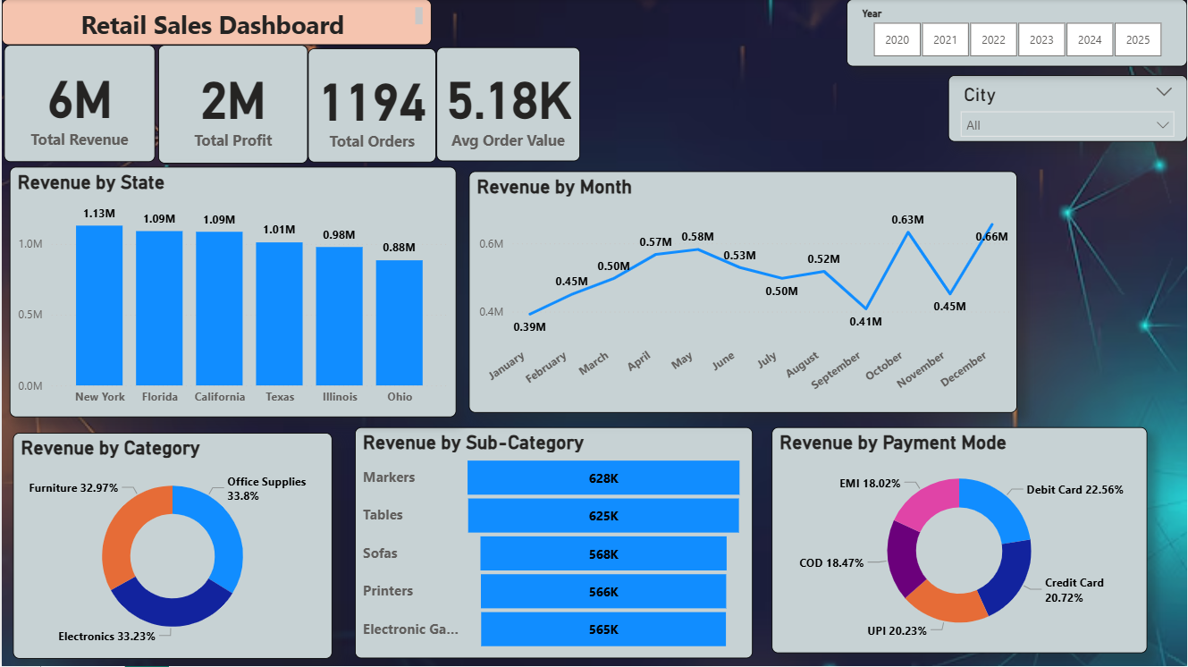

SQL (KPI)

1. Verify Data After Import

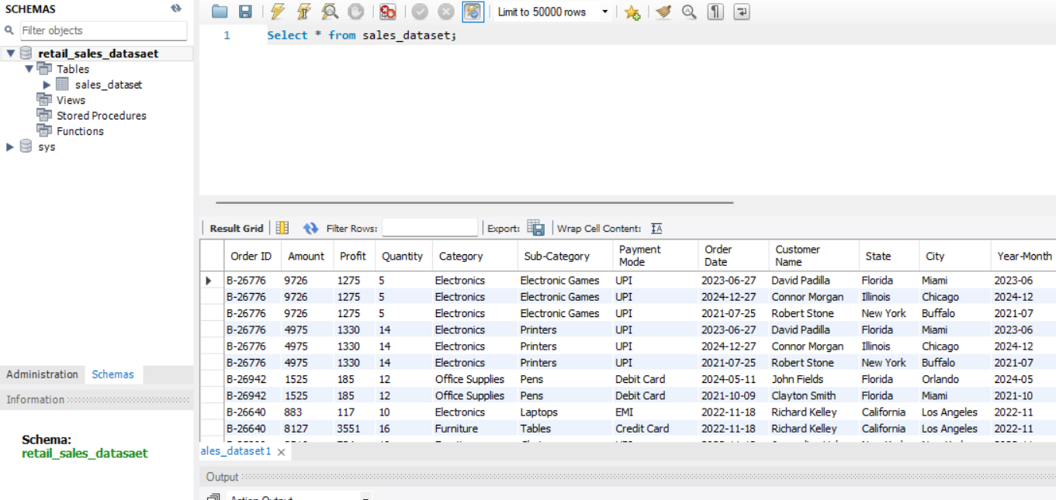

2. Counting the rows

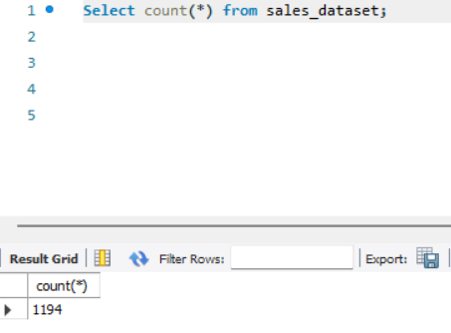

3. Total Sales & Profit
- The business generated total sales of 6 M with a profit around 2 M over the analyzed period.
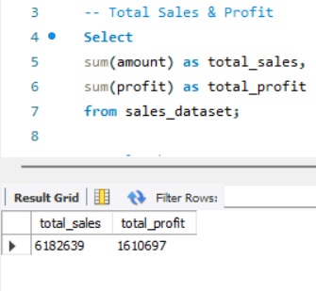
4. Sales by Category
- Office Supplies contribute the highest share of revenue.

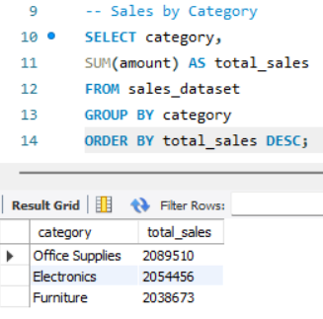

5. Top 5 Sub-Categories by Sales
- Markers and Tables are among the top-performing sub-categories.
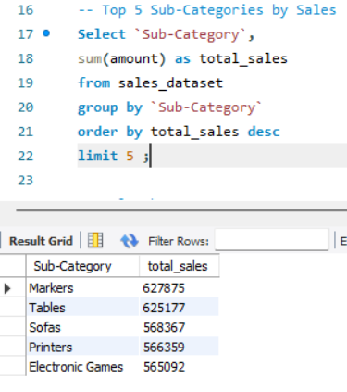

6. Sales by State
- New York and Florida generate the highest sales volumes.
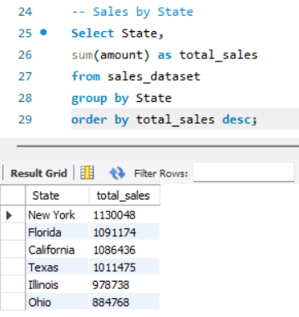
7. Monthly Sales Trend
- Sales show fluctuations across months, but in year 2022 sales goes high, indicating seasonal demand patterns.
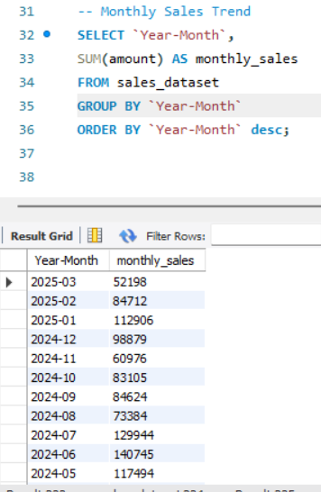
8. Payment Mode Analysis
- Debit Card and Credit Card are the most preferred payment modes.

